**EDA of COMMODITIES**

*SAKET JHA*

[SAKETJHA0324@GMAIL.COM](mailto:SAKETJHA0324@GMAIL.COM)

**Crude Oil, Natural Gas, Heating Oil, RROB Gasoline, Brent Crude Oil** & Other Fuels Futures Data.

Historical data on Fuels and Energy Futures like Oil or Gas from Kaggle

*Link To Dataset -* [*https://www.kaggle.com/datasets/guillemservera/fuels-futures-data*](https://www.kaggle.com/datasets/guillemservera/fuels-futures-data)

**About Dataset:**

This dataset provides comprehensive and up-to-date information on futures related to oil, gas, and other fuels. Futures are financial contracts obligating the buyer to purchase and the seller to sell a specified amount of a particular fuel at a predetermined price and future date.

**Use Cases:**

Trend Analysis: Scrutinize patterns and price fluctuations to anticipate future market directions in the energy sector.

Academic Research: Delve into the historical behavior of oil and gas prices and understand the influence of global events on these commodities.

Trading Strategies: Develop and test trading tactics based on the dynamics of oil, gas, and other fuel futures.

Risk Management: Utilize the dataset for hedging and risk management for corporations involved in the extraction, refining, or trading of fuels.

**Column Descriptions:**

Date: The date when the data was documented. Format: YYYY-MM-DD.

Open: Market's opening price for the day.

High: Peak price during the trading window.

Low: Lowest traded price during the day.

Close: Price at which the market closed.

Volume: Number of contracts exchanged during the trading period.

Ticker: The unique market quotation symbol for the future.

Commodity: Specifies the type of fuel the future contract pertains to (e.g., crude oil, natural gas)

**Crude Oil EDA**

**Data-frame:**

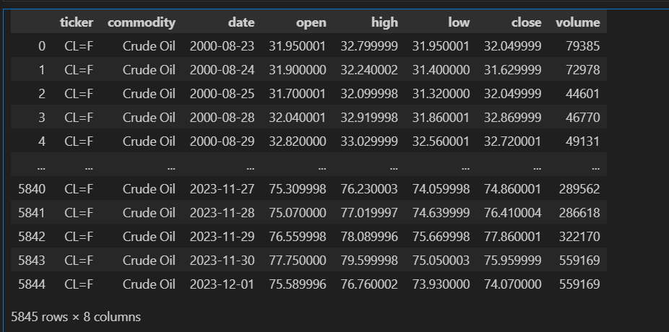

**Statistics of Dataset:**

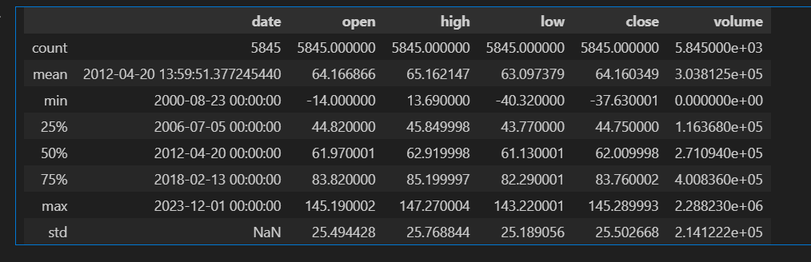

**Highlights of Statistics:**

* Crude Oil price was at its Peak on 2008-07-03 .
* Crude Oil price was at its Low on 2020-04-20.
* Mean Crude Oil High Price is $65.162147.
* STD of Crude Oil is around $25.
* Maximum Volume Crude Oil Traded is 2288230.
* On this dates Crude Oil was not traded.

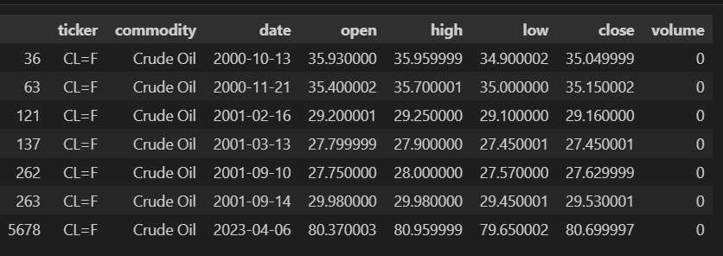

**Barplot : Year vs Crude Oil Prices :**

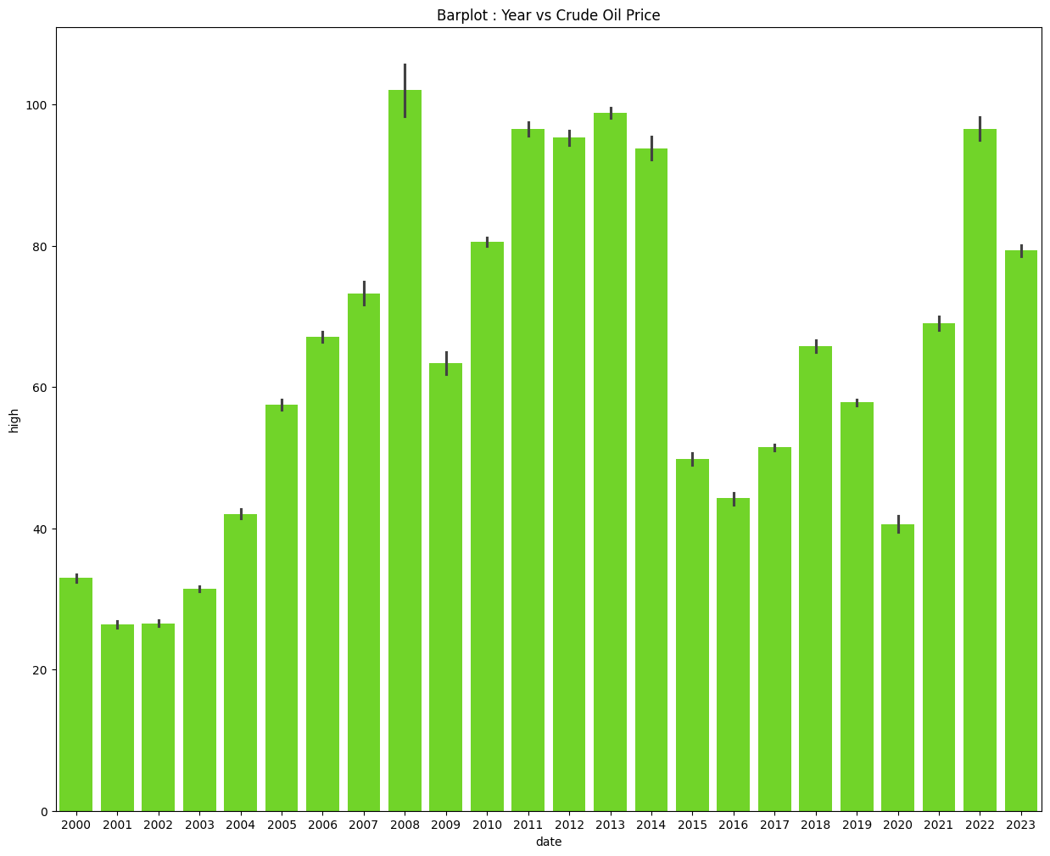

**Highlights:**

* In Year 2008 Peak of Crude Oil was Recorded.
* In Year 2020 Low of Crude Oil was Recorded.
* Balanced Years were 2011,2012,2013,2014,2022
* Prices Of Crude Oil were low in year 2004,2015,2017,2020

Crude oil: Year 2008

The high crude oil prices in 2008 were influenced by a combination of factors, contributing to a significant spike in the cost of oil during that period. Some key factors include:

**CRUDE OIL 2008 STATISTICS**

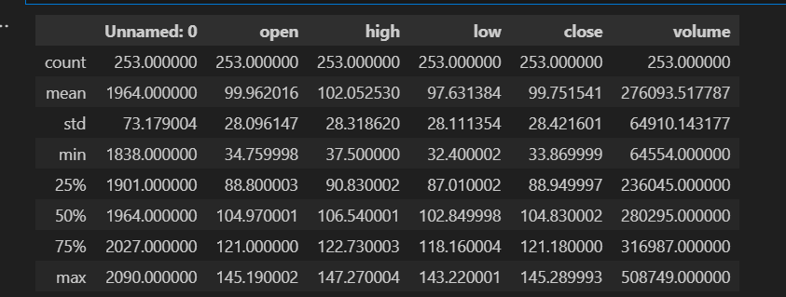

1. **Global Economic Growth**: In the years leading up to 2008, there was robust global economic growth, particularly in emerging economies like China and India. Increased economic activity typically leads to higher demand for energy, including oil.

2. **Weak U.S. Dollar**: The U.S. dollar experienced a period of weakness in the mid-2000s. Since oil is priced in U.S. dollars globally, a weaker dollar made oil more affordable for countries using other currencies, contributing to increased global demand.

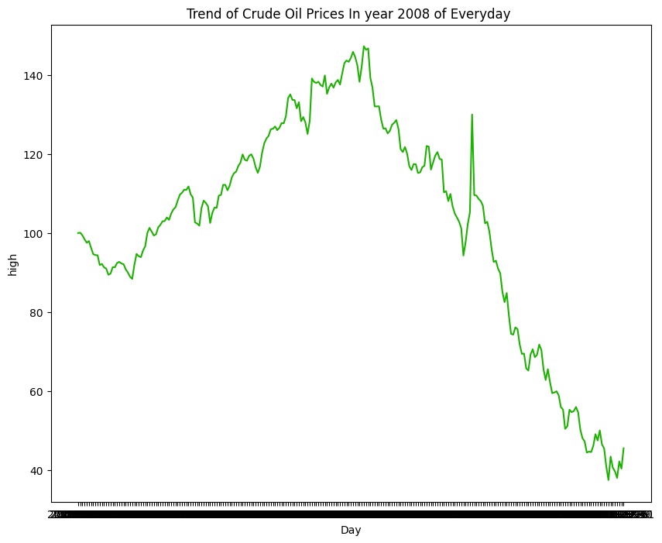

3. Supply and Demand Imbalance: There was a perceived imbalance between global oil supply and demand. Rapid economic growth in emerging markets, coupled with increased industrialization and urbanization, led to higher oil consumption. At the same time, there were concerns about the adequacy of oil production capacity to meet this growing demand.

4. Geopolitical Tensions: Geopolitical factors, including tensions in oil-producing regions, contributed to concerns about potential disruptions in the oil supply. Unrest in the Middle East, particularly in Iraq and Iran, raised concerns about the stability of oil production in the region.

5. Financial Speculation: The commodities market experienced increased financial speculation, with investors seeking returns in the commodities sector. This speculative activity contributed to higher oil prices as investors bet on the continued rise in demand.

6. OPEC Production Cuts: The Organization of the Petroleum Exporting Countries (OPEC) implemented production cuts in an attempt to support higher oil prices. These cuts, combined with geopolitical uncertainties, added upward pressure on prices.

7. Infrastructure and Refining Constraints: Bottlenecks in oil infrastructure, including refining capacity, also played a role. Limited refining capacity in some regions created concerns about the ability to convert crude oil into usable products.

The combination of these factors created a perfect storm for soaring oil prices in 2008. However, it's essential to note that the situation changed dramatically later in the year and into 2009. The global financial crisis and economic downturn led to a sharp contraction in demand for oil, causing prices to collapse from their mid-2008 highs. By the end of 2008, oil prices had fallen significantly from their peak levels.

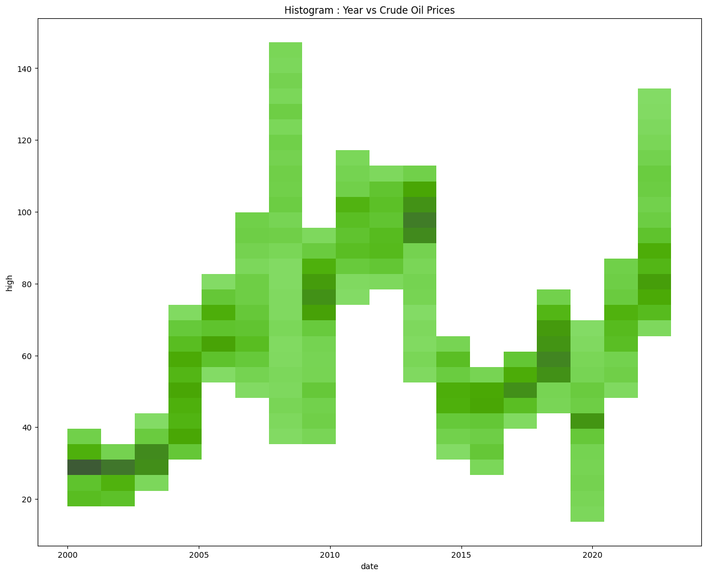

**Crude Oil : Year 2011-2014**

*The stability in crude oil prices from 2011 to 2014 can be attributed to a combination of factors that balanced the global oil market during that period. Some key factors include*:

1. Global Economic Recovery: Following the global financial crisis of 2008, there was a gradual recovery in the global economy. Economic growth, particularly in emerging markets, increased demand for oil. However, this growth was not so rapid as to create significant imbalances in supply and demand.

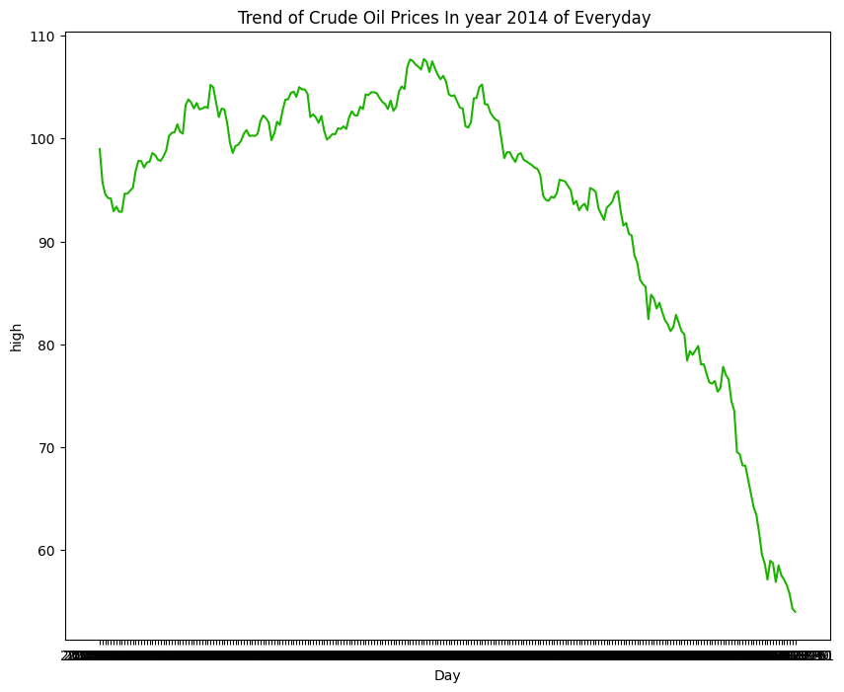

2. Increased Oil Production: During this period, there were advancements in oil extraction technologies, particularly in the United States through the development of hydraulic fracturing (fracking) techniques. This led to a surge in U.S. oil production, contributing to a more abundant global oil supply.

3. OPEC Production Levels: The Organization of the Petroleum Exporting Countries (OPEC) generally maintained stable production levels during this period. While there were occasional fluctuations, OPEC countries collectively worked to manage oil production to avoid drastic price swings.

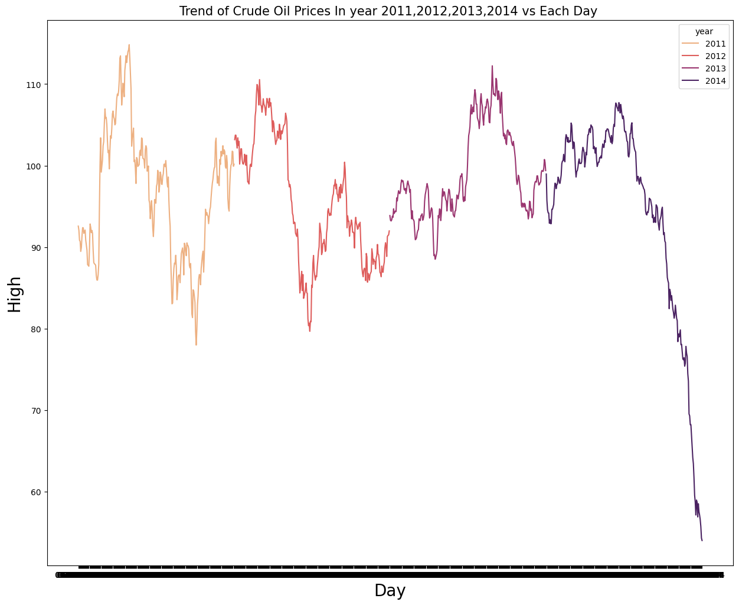

4. Geopolitical Stability: Compared to some periods of the past and future, geopolitical tensions and disruptions were relatively lower during the years from 2011 to 2014. This stability reduced concerns about potential disruptions in global oil supply.

5. Dollar Stability: The U.S. dollar remained relatively stable during this time, which also contributed to a steady oil market. Since oil is priced in U.S. dollars, a stable dollar can help maintain a sense of predictability in oil prices.

6. Global Oil Inventories: Adequate global oil inventories helped mitigate concerns about sudden shortages. The stability in inventories was partly due to the relatively balanced supply and demand dynamics during this period.

7. Demand Growth Matching Supply Increases: The gradual recovery of the global economy and the increase in oil production were, to a large extent, balanced by a corresponding rise in demand. This matching of supply and demand growth contributed to a more stable pricing environment.

It's important to note that while prices remained relatively stable during this period, they are still influenced by various factors and can fluctuate based on changes in the geopolitical landscape, economic conditions, technological advancements, and other unforeseen events. After 2014, the dynamics in the oil market started to shift again, leading to fluctuations in oil prices in subsequent years.

**Crude Oil : Year 2015-2017**

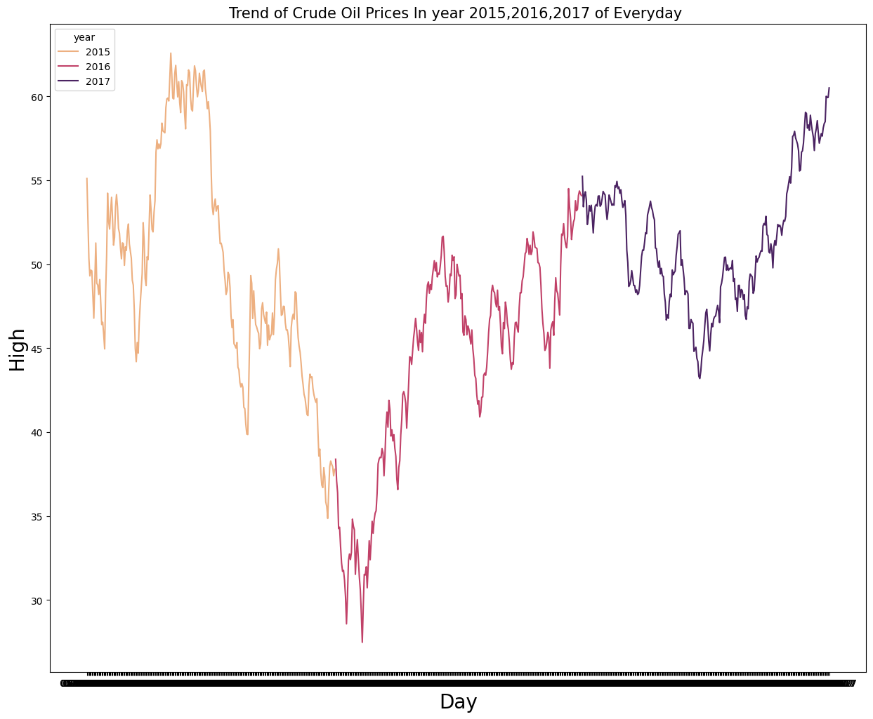

*The significant drop in crude oil prices from later half of 2015 to 2017 can be attributed to a combination of factors that created a substantial imbalance between global oil supply and demand. Some key factors include*:

1. Oversupply and Shale Revolution: One of the primary drivers was the substantial increase in oil production, particularly from the United States, driven by the shale revolution. Advances in hydraulic fracturing (fracking) and horizontal drilling allowed the U.S. to extract oil from shale formations, leading to a surge in domestic production. This added significant volumes to the global oil market, contributing to oversupply.

2. OPEC Decision Not to Cut Production: In November 2014, the Organization of the Petroleum Exporting Countries (OPEC), led by Saudi Arabia, decided not to reduce oil production levels in response to the oversupply. Instead, OPEC maintained its production levels in an attempt to protect its market share and, in some interpretations, to make shale oil production less economically viable.

3. Geopolitical Tensions: The annexation of Crimea by Russia in March 2014 escalated geopolitical tensions in the region. The move was widely condemned by the international community, leading to sanctions imposed on Russia by Western nations, including the United States and the European Union.

4. Russian Energy Exports: Russia is a major exporter of oil and natural gas, and any geopolitical tensions involving Russia can raise concerns about potential disruptions to its energy exports. These concerns may contribute to higher oil prices as traders factor in a risk premium.

5. Strong U.S. Dollar: The U.S. dollar strengthened during this time, making oil more expensive for countries using other currencies. This had a dampening effect on global oil demand.

6. Market Reaction: Following the annexation of Crimea, there was a short-lived spike in oil prices as markets reacted to the geopolitical uncertainties. However, the impact on oil prices was relatively limited compared to other factors influencing the market at the time.

The combination of these factors led to a significant oversupply of oil in the global market, causing prices to plummet. The price of crude oil dropped from over $100 per barrel in mid-2014 to below $30 per barrel in early 2016. The period from 2014 to 2017 marked a challenging time for oil-producing countries and companies, as they had to adjust to the new market realities and lower oil prices.

**Crude Oil : Year 2018-2020**

**Statistics**

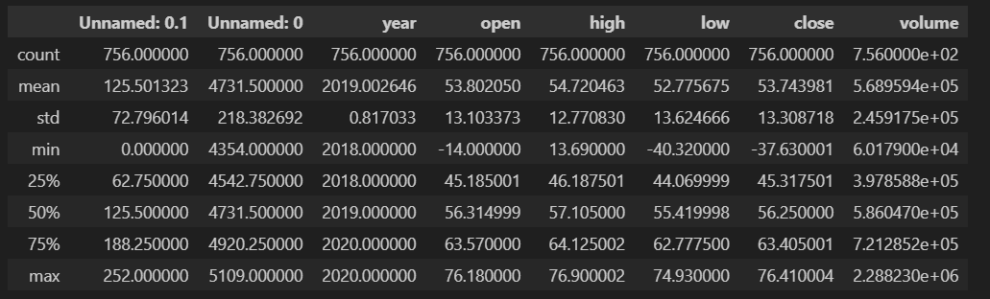

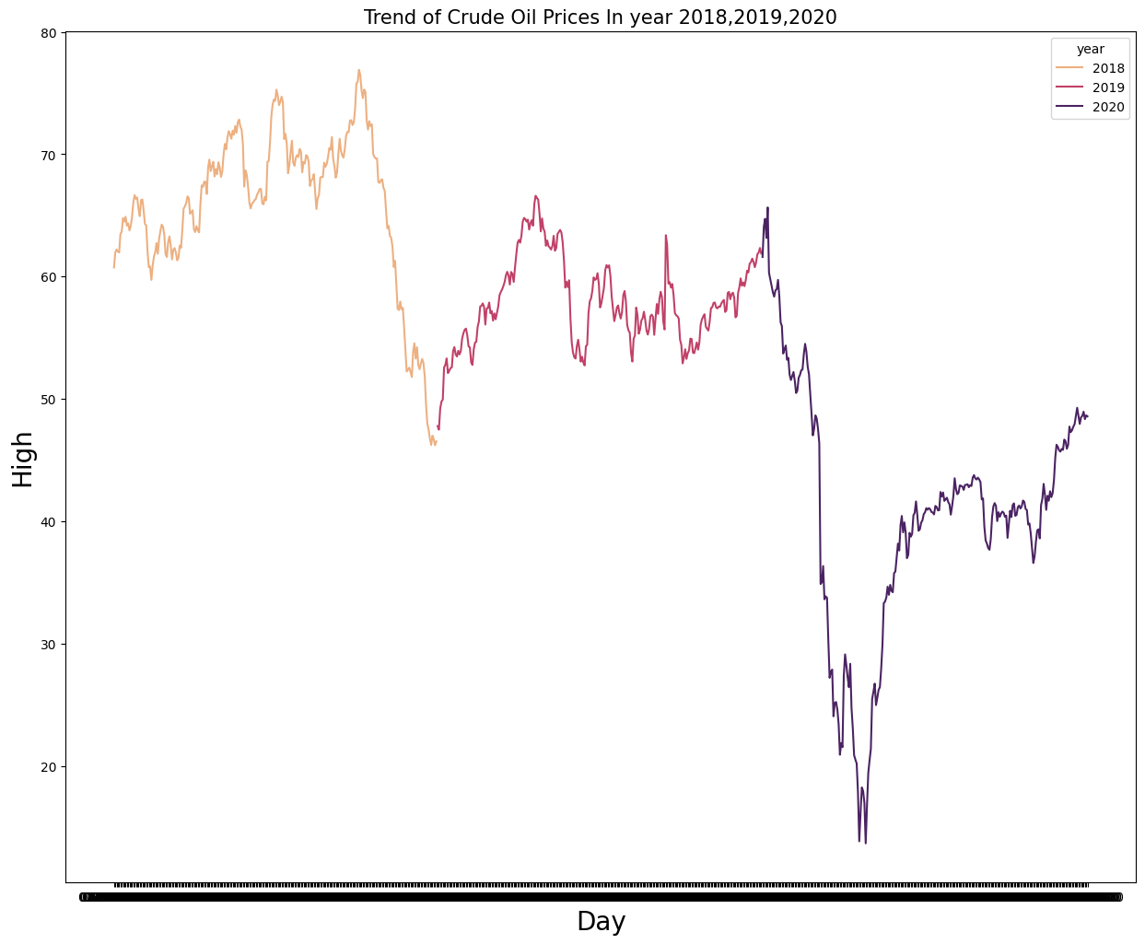

The outbreak of the COVID-19 pandemic in late 2019 had far-reaching implications across various sectors of the global economy, and the oil and gas industry was no exception. This report aims to provide a detailed analysis of the impact of COVID-19 on crude oil prices, examining the key factors that influenced the fluctuations and the industry's response.

**Initial Shock and Demand Destruction:**

The first major blow to crude oil prices came as countries implemented lockdowns and travel restrictions to curb the spread of the virus. With businesses shutting down, flights grounded, and people staying at home, the demand for oil plummeted. This sudden demand destruction triggered a sharp decline in crude oil prices, as the market faced an oversupply situation.

**OPEC+ and the Price War:**

Concurrently, a significant event unfolded in the oil markets as the OPEC+ alliance, led by Saudi Arabia and Russia, failed to reach an agreement on production cuts in March 2020. This led to a price war, with both nations increasing oil production to gain market share. The combination of the demand slump and the supply surge contributed to a historic collapse in oil prices, with West Texas Intermediate (WTI) briefly turning negative in April 2020.

**Government Interventions and Production Cuts:**

Recognizing the severity of the situation, major oil-producing nations, including OPEC, OPEC+ members, and the G20, intervened to stabilize the market. Several agreements were reached to implement significant production cuts to rebalance supply and demand. These interventions played a crucial role in preventing a prolonged period of extremely low oil prices.

**Global Economic Recovery and Oil Demand Rebound:**

As countries gradually lifted restrictions and initiated vaccination campaigns, the global economy started on the path to recovery. This led to a rebound in oil demand, particularly in sectors such as transportation and manufacturing. The positive sentiment surrounding economic recovery contributed to a gradual increase in crude oil prices.

**Volatility and Uncertainty:**

Despite the recovery, the oil market remained volatile, with uncertainties surrounding new COVID-19 variants, geopolitical tensions, and the pace of economic revival. This volatility made it challenging for market participants to accurately predict future price movements.

**Energy Transition and Long-Term Implications:**

The COVID-19 pandemic accelerated discussions around the energy transition, with increased emphasis on sustainable and renewable energy sources. As the world reevaluates its energy policies, the oil and gas industry faces long-term challenges, including potential shifts in investment patterns and changes in consumer behavior.

**Conclusion:**

In conclusion, the impact of COVID-19 on crude oil prices was multifaceted, involving a sudden demand collapse, a price war, and subsequent interventions to stabilize the market. While the industry has shown resilience in adapting to changing circumstances, the long-term implications include considerations for energy transition and a potential restructuring of the global oil market. Monitoring these trends will be essential for stakeholders in navigating the evolving landscape of the oil and gas industry.

**Crude Oil : Year 2021 to 2023**

**STATISTICS**

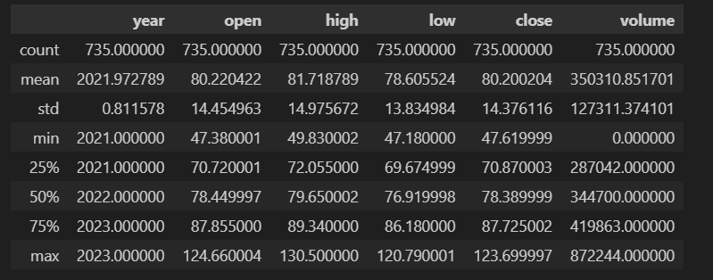

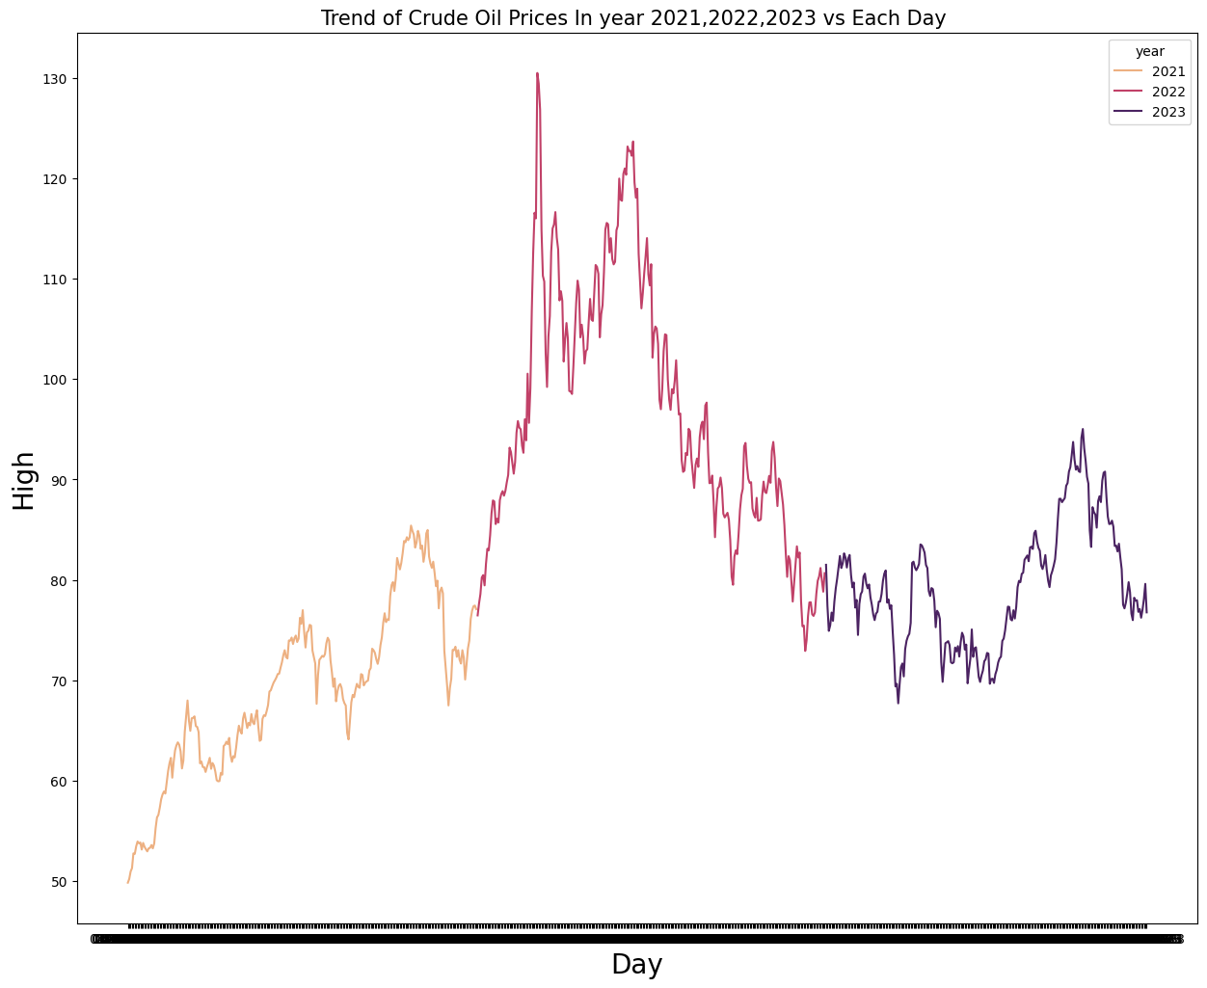

**Introduction:**

The period from 2021 to 2023 witnessed significant fluctuations in crude oil prices, shaped by a multitude of factors, including the ongoing recovery from the COVID-19 pandemic, geopolitical events, and global economic dynamics. This report aims to provide a comprehensive analysis of the trends in crude oil prices during this timeframe.

**Global Economic Recovery and Demand Dynamics:**

The years 2021 to 2023 marked a gradual but uneven global economic recovery from the impacts of the COVID-19 pandemic. As vaccination efforts progressed, many countries saw increased economic activity, contributing to a rise in the demand for oil. Sectors such as transportation and manufacturing, which were heavily affected in the previous years, showed signs of resurgence.

**OPEC+ Actions and Production Policies:**

The Organization of the Petroleum Exporting Countries (OPEC) and its allies (OPEC+) played a crucial role in influencing oil prices during this period. OPEC+ continued to implement production adjustments to balance the market, responding to evolving demand and supply dynamics. Decisions on production quotas had a direct impact on oil prices and market stability.

**Geopolitical Events and Supply Disruptions:**

Geopolitical events, including tensions in the Middle East and production disruptions in key oil-producing regions, contributed to periodic spikes in oil prices. Conflicts and geopolitical uncertainties influenced market sentiment, creating volatility in crude oil prices.

**Energy Transition and ESG Considerations:**

The focus on environmental, social, and governance (ESG) factors gained prominence during this period. Increasing emphasis on sustainability, coupled with the global push towards renewable energy sources, impacted investor perceptions and influenced capital allocation within the oil and gas industry. These factors had implications for long-term oil price trends.

**Inflation and Economic Policy:**

Inflationary pressures and central bank policies also played a role in shaping oil prices. The response of central banks to inflation concerns, interest rate decisions, and fiscal policies had repercussions on global economic conditions, thereby influencing oil market dynamics.

**Technological Advances and Industry Efficiency:**

Advancements in technology and improved operational efficiency within the oil and gas sector contributed to the industry's ability to navigate changing market conditions. Innovations in extraction techniques, exploration technologies, and operational practices influenced production costs and overall market dynamics.

**Future Outlook and Risks:**

As we look ahead, the future of crude oil prices remains subject to a range of uncertainties. Ongoing geopolitical tensions, the pace of the energy transition, and global economic developments will continue to impact oil markets. Additionally, unforeseen events such as natural disasters or public health crises could introduce further volatility.

The analysis of crude oil prices from 2021 to 2023 underscores the complex interplay of factors influencing the market. Stakeholders in the oil and gas industry must remain vigilant, adapting strategies to navigate evolving dynamics, including geopolitical shifts, technological advancements, and the ongoing global transition towards sustainable energy sources. A comprehensive understanding of these factors will be crucial for informed decision-making in the coming years.